

**MH Digital ID**

**SYSTEM OPERATION DOCUMENT**

**MAB/GROUP IT/SOD/MHDigital ID/V1.0**

##### Prepared by :

##### AMS Team

##### Application Management Services (AMS)

##### Group IT

**ALL INFORMATION CONTAINED HEREIN IS RESTRICTED AND SHALL BE KEPT FOR INTERNAL USE ONLY**. None of this information shall be divulged to persons other than Malaysia Airlines Berhad employees and contractors authorized by the nature of their duties to receive such information, or individuals or organisations authorised by Malaysia Airlines Berhad in accordance with existing policy regarding release of company information.

**INTENTIONALLY LEFT BLANK**

|  |  |  |  |  |  |  |  |
| --- | --- | --- | --- | --- | --- | --- | --- |
|  | |  | |  | |  | |
| Prepared By | | : | |  | |
|  | |  | | Krishnakant Bairagi | |
|  | |  | | AMS Team | |
|  | |  | | Application Management Services | |
|  | |  | |  | |
| Reviewed By | | :  : | | |  | | --- | |  | | Manish Barapatre | | OST Tower Manager | | Group IT | | |
|  | |  | | Noor Hafiza Bahruddin | |
|  | |  | | IT - Service Delivery Management | |
|  | |  | | Group IT | |
|  | | : | |  | |
|  | |  | | Mohd. Suhaimi Yusof | |
|  | |  | | Head.IT Business IT Operations  IT- Business IT Operations | |
|  | |  | |  | |
| Approved By | | : | |  | |
|  | |  | | Siti Hafsah Mohd Desa | |
|  | |  | | Head IT Service Delivery Manager | |
|  | |  | | Group IT | |

**INTENTIONALLY LEFT BLANK**

**TABLE OF CONTENTS**

**Contents Page**

**PART 1** **- MANUAL ADMINISTRATION 1-1**

**1.1.** **RECORD OF REVISION 1-2**

**1.2.** **LIST OF EFFECTIVE PAGES 1-2**

**1.3.** **DISTRIBUTION LIST 1-2**

**1.4.** **LIST OF ABBREVIATIONS 1-2**

**1.5.** **CONDITION OF USE 1-3**

**1.6.** **CONTROL OF MANUAL 1-3**

**PART 2** **- MANUAL BACKGROUND 2-1**

**2.1** **INTRODUCTION 2-2**

**2.2** **PURPOSE 2-2**

**2.3** **SCOPE AND APPLICATION 2-2**

**2.4** **TERMINOLOGY 2-2**

**2.5** **REFERENCES 2-2**

**PART 3** **- OVERVIEW OF BUSINESS PROCESS 3-1**

**3.1** **OVERVIEW OF BUSINESS PROCESS 3-2**

**PART 4** **- MANUAL CONTENT TITLE 4-1**

**4.1** **Systems overview 4-2**

4.1.1 System Concept Diagram 4-2

4.1.2 MH DIGITAL ID - System Usage 4-3

**4.2** **INTERFACES 4-12**

4.2.1 User Interfaces 4-12

4.2.2 System Interfaces 4-13

**4.3** **WARRANTY AND MAINTENANCE PERIOD 4-13**

**4.4** **ROLES AND RESPONSIBILITIES 4-14**

**4.5. TECHNICAL SPECIFICATIONS** **4-15**

4.5.1 Hardware specifications 4-15

4.5.2 Software specifications 4-17

4.5.3 Communication / Network Specification 4-17

4.5.4 User and Equipment Locations 4-17

4.5.5 File Management 4-17

**4.6** **TECHNICAL OPERATIONS GUIDE 4-18**

4.6.1 Backup and Recovery 4-18

4.6.2 Monitoring Tools 4-18

4.6.3 Source Code Version Control 4-18

4.6.4 Preparation of Production Environment 4-19

**4.7** **Maintenance and support 4-19**

4.7.1 Problem Logging 4-20

4.7.2 Problem Categorization and Escalation 4-20

4.7.3 Application / Technical Support 4-20

**4.8** **User guide 4-20**

4.8.1 Accessing the Application 4-21

**4.9** **Contract management 4-21**

**4.10** **INFORMATION SECURITY 4-22**

4.11.1 Audit and Compliance Requirements 4-23

4.11.2 Password Policy Compliance 4-23

4.11.3 User Access Matrix 4-23

**4.11 DOCUMENTATION AND REFERENCES 4-23**

**AppendiX i**

1. - MANUAL ADMINISTRATION

# RECORD OF REVISION

| **No.** | **Description Of Changes** | **Issue No.** | **Rev. No.** | **Author** | **Effective Date** |
| --- | --- | --- | --- | --- | --- |

# LIST OF EFFECTIVE PAGES

|  |  |  |  |  |  |  |  |  |  |
| --- | --- | --- | --- | --- | --- | --- | --- | --- | --- |
| **Part** | **Page** | **Issue No.** | **Revision No.** | **Effective Date** |  | **Page** | **Issue No.** | **Revision No.** | **Effective Date** |

# DISTRIBUTION LIST

|  |  |  |
| --- | --- | --- |
| **NAME** | **DEPT / AREA** | **DESIGNATION** |
| Nurazniyati Abd Wahid | Operations BIT | BU |
| Mohd Suhaimi Yusuf | Operations BIT | System Owner |
| Siti Hafsah Mohd Desa | Group IT | Head IT SDM |
| Wan Mohd Husni Wan Hussein | AMS | AMS SDM |

# LIST OF ABBREVIATIONS

The following are the abbreviations used for the purpose of simplification.

|  |  |
| --- | --- |
| **Abbreviation** | **Denote** |
| MD | Managing Director |
| CFO | Chief Financial Officer |
| NRM | Network and Revenue Management |

# CONDITION OF USE

* + 1. This manual is the property of Malaysia Airlines Berhad.
    2. All copies assigned to individual position(s), section(s) or station(s) is on loan basis. If, for any reason, the position(s), section(s) or station(s) is abolished from the company organization, the respective copy(ies) of the manual must be returned to Head IT Service Delivery Manager.
    3. In the event where the title of the position or section is changed, the department concerned shall inform Head IT Service Delivery Manager promptly.
    4. The content of this manual shall not be copied, or communicated in part or as a whole, to any person not employed by the Company without the express written consent of the Head IT Service Delivery Manager.
    5. It is the responsibility of the holder to ensure that his copy is updated to the latest amendments and is in good state of condition.

# CONTROL OF MANUAL

* + 1. The contents of this manual shall not be deleted, added, or altered in any way without the approval of the Head IT Service Delivery Manager.
    2. Any page which carries an amendment must bear the new revision date. Any line which is amended shall be highlighted by a revision bar (i.e. dark vertical line) drawn close to the amended text on the outside border of the document.
    3. A transmittal letter must accompany the amended pages to advise the holders how to effect the amendment to their copies.
    4. Holders shall notify this department in writing for loss of manual and to obtain a replacement copy. Head IT Service Delivery Manager shall ensure that this manual reviewed at least once a year and effect necessary amendments as and when necessary. Should any person(s) envisage improvements needed for the contents of this manual, the person should direct the request to the Head IT Service Delivery Manager.

**INTENTIONALLY LEFT BLANK**

1. - MANUAL BACKGROUND

# INTRODUCTION

This is the MH Digital ID SOD, hereinafter referred to as “the Policy” provides comprehensive operating procedures within the scope and application herein defined in Part 2 Section 3.0 for Malaysia Airlines Berhad (MAB).

# PURPOSE

The objective of this document is to provide relevant information required to support and maintain MH Digital ID application.

# SCOPE AND APPLICATION

This document covers relevant information required to support and maintain the MH Digital ID applications in production. This covers the maintenance operation of the system and interfaces.

# TERMINOLOGY

|  |  |  |
| --- | --- | --- |
| **S.No** | **Term** | **Description** |
| 1. | AMS | APPLICATION MANAGEMENT SERVICES |
| 2. | LAN | LOCAL AREA NETWORK |
| 3. | LDAP | LIGHTWEIGHT DIRECTORY ACCESS PROTOCOL |

# REFERENCES

|  | **Document** | **Description** |
| --- | --- | --- |
| 1 | N/A |  |

1. - OVERVIEW OF BUSINESS PROCESS

# OVERVIEW OF BUSINESS PROCESS

* MH Digital ID Application is used to view user profile, QR Code and Edit profile via mobile on Intranet.
* Figure 1 shows the overall server & client architecture of the application.

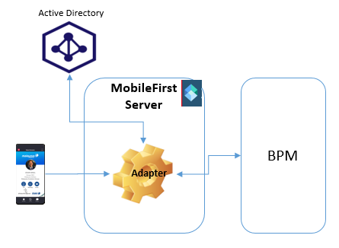

Figure 1 – MH Digital ID Overview

PART 4- MANUAL CONTENT TITLE

4.1 Systems overview

MH Digital ID application is developed using Open Source software (OSS) such as HTML, CSS, Ionic, and Java.

## 4.1.1 SYSTEM CONCEPT DIAGRAM

Figure 2 & Figure 3 shows the architecture of the application

**Mobile Applications**

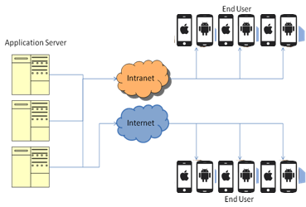

Figure 2 – System Overview for Mobile

## 4.1.2 MH DIGITAL ID - System Usage

**User Profile**

* MH Digital ID mobile app has auto registration feature for which users has to provide MH Staff ID & domain password to get registered.

Below figure shows the sample screen for user profile in the application

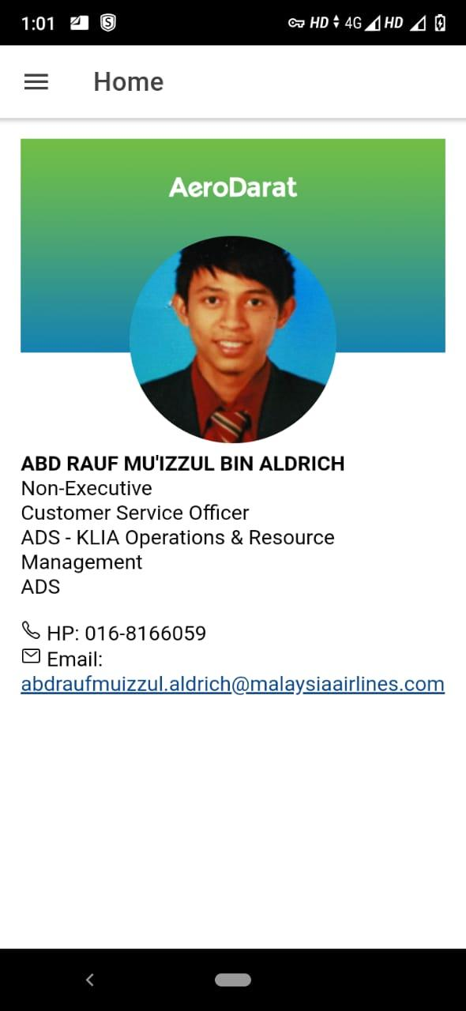

Figure 4 – User Profile

**QR Code-** This is used to display QR code of the user that will help to get user profile in Bizcard.

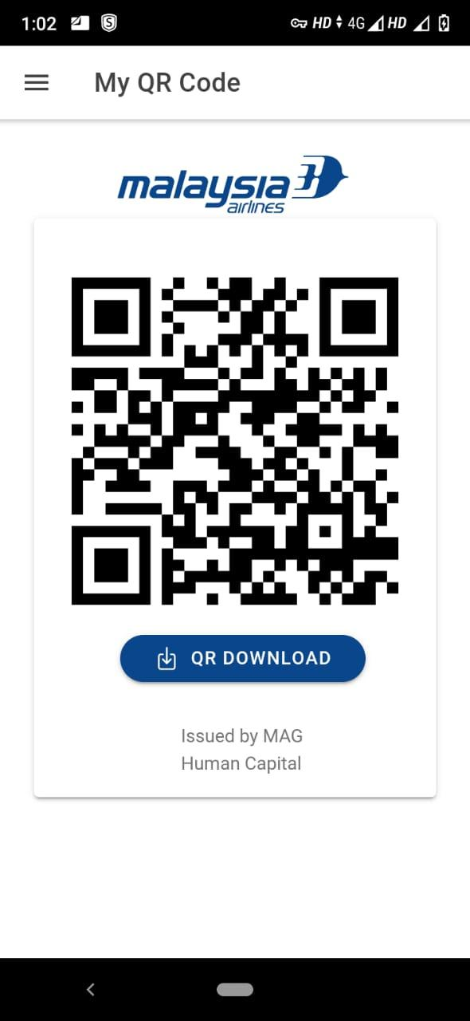

Figure 6 – QR Display

**EDIT PROFILE-**This is used to update user info like profile picture and custom data.

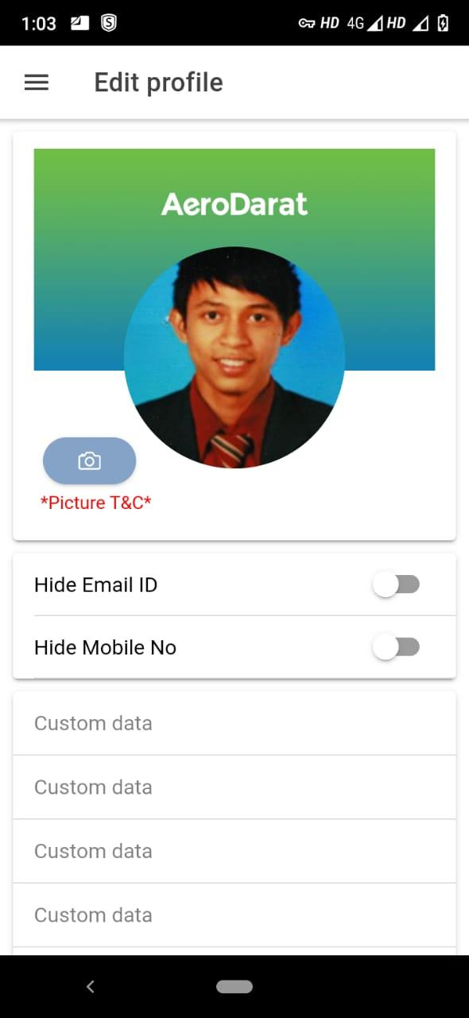

Figure 6 – Edit Profile

# 4.2 INTERFACES

## 4.2.1 USER INTERFACES

MH Digital id application can be accessed through Android and IOS mobile over Intranet.

## 4.2.2 SYSTEM INTERFACES

* MH Digital ID is using LDAP to authenticate user. User can login into application using MH domain credentials and it will be validated using LDAP validator.
* BPM Interface: MH Digital ID is interfaced to the BPM using web services to perform user profile,QR code and edit profile functionality.

# 4.3 WARRANTY AND MAINTENANCE PERIOD

Below table shows the warranty & maintenance period of the application.

|  |  |  |
| --- | --- | --- |
| **Warranted Items** | **Start Date** | **End Date** |
| Maintenance and Support | 03-Aug-2021 | 31-Apr-2024 |

Table 8- Warranty & Maintenance Period

# 4.4 ROLES AND RESPONSIBILITIES

The roles & responsibilities of the application is shown below

|  |  |  |  |  |  |
| --- | --- | --- | --- | --- | --- |
| **Role** | **Responsibility** | **Name** | **Designation** | **Company / Department** | **Contact (Phone & Email)** |
| MAB Group IT Infrastructure Group  (Midrange Team) | * Responsible for maintaining MH Digital Id infrastructure. * Responsible backup and restore activity for MH Digital Id * Responsible for maintaining web server. * Responsible for troubleshooting infrastructure related problems. * Responsible for deployment of mobile and Adapter app. * Responsible for maintaining Mobile first server and App center. |  | IBM Team/Infra team | IBM/TCS |  |
| MAB Helpdesk | * As single point of contact to coordinate when MH Digital Id problems occurred. * Responsible to coordinate problem reporting to the respective parties | - | - | - | helpdesk@malaysiaairlines.com  +6 03 7863 2020 |
| Application Support (AMS) | * Responsible for maintaining MH Digital Id application as second level support. * Assess OneIT request for MH Digital Id. * Develop and unit testing new MH Digital Id request * Coordinate UAT with BU. * Work with Infra to deploy new MH Digital Id application. * Work with infra team to deploy Android and ios build. | Krishnakant Bairagi | SSE | ATOS/AMS | ext_krishnakant.bairagi@malaysiaairlines.com |
| BPM Application support |  | Rajendra prasad |  |  |  |

Table 9 – Roles & Responsibilities

*Note: Proper handover must be performed if there is any change to the above roles and the matrix will be updated accordingly.

# 4.5 TECHNICAL SPECIFICATIONS

## 4.5.1 Hardware specifications

The hardware specifications of the application is shown below

|  | **Category** | **Configuration** |
| --- | --- | --- |
| 1 | Production Application Server | PROD DETAILS |
| 2 | UAT Application Server  (Mobile First) | **URL :** <https://10.224.4.35:9443/>  **IP :** 10.224.4.35 |
| 3 | UAT Application Server  (BPM) | **URL:** : <https://10.224.18.25/rest/bpm/wle/v1/service/MHSDID@MHID_UPDATE_USER_INFO>  **IP :** 10.224.18.25 |

Table 11 – Hardware Specifications

## 4.5.2 Software specifications

Software specifications are shown below

|  |  |  |
| --- | --- | --- |
|  | **Category** | **Configuration** |
| 1 |  |  |

Table 12 – Software Specifications

**4.5.3 COMMUNICATION / NETWORK SPECIFICATION**

The server is accessible through VPN connection. Users using their desktop browser can access the application over the LAN connection to the server. The current supported browser is Google Chrome

The network specifications are shown below

|  |  |  |
| --- | --- | --- |
|  | **Category** | **Configuration** |
| 1 | 9444 | <https://10.224.4.35:9443/mfpconsole/index.html> |

Table 13 – Communication Specification

## 4.5.4 User and Equipment Locations

MH Digital ID application is used by various departments in MAB. Users and user’s equipment locations are distributed over MAB network at the various departments and stations.

## 

## 4.5.5 File Management

N/A

# 4.6 TECHNICAL OPERATIONS GUIDE

NA

### 4.6.1 Backup and Recovery

Please find server backup details below.

|  |  |  |  |  |
| --- | --- | --- | --- | --- |
| **Hostname** | **Version** | **Schedule** | **Frequency** | **Remarks** |
| **Mobile App and Adapter Application backup should be performed on monthly basis.** | | | | |

Table 15 – Server Backup Details

## 4.6.2 Monitoring Tools

MH Digital ID systems will be monitored by AMS Team.

## 4.6.3 Source Code Version Control

1. Source code is managed by AMS Team on SVN.

## 4.6.4 Preparation of Production Environment

### 4.6.4.1 Program / Macro

Mobile First server and BPM Server running.

### 4.6.4.2 Network Definitions

All users mobile devices (iOS & Android) are connected to MH Network to access MH Digital ID Application.

.

### 4.6.4.3 Mobile Configuration

1. iOS 9.0 & above
2. Android 4.4.2 & above
3. Target Mobile Application Installed

## 4.6.5 Batch Jobs

N/A

## 

## 4.6.6 Report Management

N/A

## 

## 4.6.7 Baseline Performance Information

MH Digital ID is classified as a Business Criticality Definition (BCD) level 2 applications. There is Disaster Recovery capability for this application. In the event of disaster recovery, the application will be available.

# 

# 4.7 MOBILE APP DEPLOYMENT PROCEDURE

Microsoft App center is used for distributing mobile app internally to all MH Digital ID users under MAB

Following are the procedure for distributing mobile apps

* Prepare the executable files for both Android & iOS platform from respective build tools.
* Login into App center and choose the organization “Malaysia Airlines Berhad”
* Under Apps, it will list down all the Apps released by “Malaysia Airlines Berhad”
* Choose MH Digital ID with OS type iOS or Android
* Distribution procedure for both Android & iOS remains same in Appcenter
* Once you choose an App, it will redirect to App overview page
* Look for the option “Distribute” under left hand side of the page
* Under Distribution, click on “Groups” and it will list down all the groups created for the app distribution
* Add any new users using their MAB email under the distribution group
* Look for New Release option to start the deployment of a build
* Upload APK file in case of Android and IPA file in case of iOS
* On next screen, fill in appropriate release notes for the build
* On proceeding to next screen, click on distribute to complete the deployment procedure
* All the users will now receive an email from Appcenter for the new release and installation steps are provided under installation guide
* Any new user should receive the signup email from Appcenter, they should complete the registration process before installing the app. Procedures are provided under installation guide

## 4.7.1 Mobile App Installation Guide

Please refer to Documentation and references section

## 4.8 Maintenance and support

The maintenance MH Digital ID operations team as listed below

|  |  |  |
| --- | --- | --- |
|  | **Type of Support** | **Contact Details** |
| 1 | IT Helpdesk  (1st Level Support) | (603) 7840-2020, 1-800-88-1173  helpdesk@malayasiaairlines.com |
| 2 | Group IT Operations  (2nd Level Support) | Application Support  GD_AMS @malaysiaairlines.com |

Table 17 - Maintenance & Support

## 4.8.1 Problem Logging

MAB IT Helpdesk will handle upon any issue / problem in production.

## 4.8.2 Problem Categorization and Escalation

Helpdesk will analyze the problem and assign a ticket number and a severity level which is mutually agreed by the user based on the Group IT SLA.

For all non-application related problems, Helpdesk will channel the problem ticket to the respective support from Infra-Network problems.

MH Digital ID is categorized as a business critical application (BCD2), and there should be Severity 1 or 2 or 3 incident expected for MH Digital ID .

## 4.8.3 Application / Technical Support

|  |  |  |
| --- | --- | --- |
| **Name** | **Responsibility Area** | **Contact (Email)** |
| IT Helpdesk | L1 support | [helpdesk@malaysiaairlines.com](mailto:helpdesk@malaysiaairlines.com) |
| Krishnakant Bairagi | Application Support | [ext_krishnakant.bairagi@malaysiaairlines.com](mailto:ext_krishnakant.bairagi@malaysiaairlines.com) |
| Group ID | MH Digital ID support team | GD_AMS_ @malaysiaairlines.com |

Table 18 - Technical Support

# 

# 4.9 USER GUIDE

The high-level descriptions of the MH Digital Id application modules are as below:

|  |  |
| --- | --- |
| **Title** | **MH Digital ID** |
| **Reference** | http://svn.mas.net/svn/SRAS/BPM_BizCard/MobileSRC |
| **Description** | MH Digital ID Application |
| **URL** |  |
| **No. of Users** |  |
| **Owner / Key User and Contact Info** | Mohd. Suhaimi Yusof |
| **Integration / Interfaces** | BPM Rest Service |

Table 19 – User Guide

## 4.9.1 Accessing the Application

Mobile applications can be accessed by users via their mobile devices connected to MH Network.

# 

# 4.10 CONTRACT MANAGEMENT

Contractor / Vendor relationship will be managed via the following contracts.

|  |  |  |
| --- | --- | --- |
| **No** | **Contract** | **Parties** |
| 1. | Service contract from AMS support service | Signed between MAB and ATOS |

Table: Contract Management

# 4.11 INFORMATION SECURITY

## 4.11.1 Audit and Compliance Requirement

Below are the audit & compliance requirements of the application

|  |  |  |
| --- | --- | --- |
| **Activity** | **Frequency** | **Responsible Party** |
| Perform ID review every quarter and submit result to IRS  [Req: ISO 27001, PCI-DSS] | Quarterly | ID Admin |
| Update user access matrix and submit to IRS  [Req: ISO 27001, PCI-DSS] | Yearly | System Owner |
| Install Critical Security Patches for the application and submit report to IRS  [Req: ISO 27001, PCI-DSS] | Quarterly | System Owner |
| Performed Backup restoration  [Req: ISO 27001, PCI-DSS] | Yearly | System Owner |
| Review & update security documentation and submit to IRS:   * Super/privilege IDs and access * Security Controls Setting * Audit Logs setting * System bypass * List of connections and integration * List of used ports * Data encryption setting * Application/system schematic diagram   [Req: ISO 27001] | Yearly | System Owner |

Table 20 - Audit & Compliance Requirement

## 4.11.2 Password Policy Compliance

Application follows the below password policy compliance

|  |  |  |  |  |
| --- | --- | --- | --- | --- |
|  | **Password Policy Requirements** | **Yes** | **No** | **Remarks** |
|  | Password length at least 8 characters (minimum) | Yes |  |  |
|  | Alphanumeric | Yes |  |  |
|  | Change temporary password at first logon | Yes |  |  |
|  | Password expiry = 90 days (maximum) | Yes |  |  |
|  | Password reuse generation = 5 (minimum) | Yes |  |  |
|  | Account lock out after 5 failed login attempts | Yes |  |  |
|  | Application shall disconnect or suspend inactive sessions= 15 Minutes | Yes |  |  |
|  | Wrong password shall be recorded in an audit log | Yes |  |  |

Table 21 - Password Policy Compliance

## 4.11.3 USER ACCESS MATRIX

The user level access matrix of the application is shown below

|  |  |  |  |  |  |
| --- | --- | --- | --- | --- | --- |
| **USER ID/ Common ID** | **USER TYPE** | **ACCESS LEVEL** | | | |
| **Update** | **View** | **Edit** | **Delete** |
|  | Normal | Y | Y | Y |  |

Table 22 – User Access Matrix

Note: Refer Owner / Key User for each application under User Guide table for administrator role.

# 

# 4.12 DOCUMENTATION AND REFERENCES

Following are the soft copy documentation location

|  | **Document** | **Location and reference** |
| --- | --- | --- |
| 1 | System Operation Document  (soft copy of this document) |  |
| 2 | Mobile App Installation Guide (Android & iOS) |  |

Table 23 - References

**APPENDIX**

**Change Request**

|  |  |  |  |  |
| --- | --- | --- | --- | --- |
| **Change request** | **Date** | **Description** | **MH fix Included?** | **Impacted version** |

**PATCH MANAGEMENT REPORT**

Application : _______NIL______________________________________________

Owner **: _______**NIL**______________________________________________**

|  |  |
| --- | --- |
| **Date** | **Patch / Service Pack Applied** |
| NIL | NIL |
|  |  |
|  |  |
|  |  |

**Prepared By: Approved By:**

**.................................................... ....................................................**

**System Admin System Owner**

**BACKUP RESTORATION REPORT**

Application : ______NIL________________________________________________

Owner : ______NIL________________________________________________

|  |  |
| --- | --- |
| **Date** | **Status of Restoration** |
| **NIL** | **NIL** |
|  |  |
|  |  |
|  |  |

**Prepared By: Approved By:**

**.................................................... ....................................................**

**Backup Admin System Owner**

**NON COMPLIANCE REPORT**

Application : ______NIL______________________________________________

Owner **: ______**NIL**_______________________________________________**

|  |  |  |
| --- | --- | --- |
| **Date** | **Reference Number** | **Description** |
| **NIL** | **NIL** | **NIL** |
|  |  |  |
|  |  |  |
|  |  |  |

**Prepared By: Approved By:**

**.................................................... ....................................................**

**System Admin System Owner**

**END OF DOCUMENT**